**WEB TECHNOLOGY**

Name: **KULDEEP**

Roll No. : 00814807216

Semester: 6th

Group: C-12



Maharaja Agrasen Institute Of Technology, PSP Area,

Sector-22, Rohini, New Delhi-110086

**WEB TECHNOLOGY**

**PAPER CODE** : **ETCS-308**

NAME OF THE STUDENT : KULDEEP

UNIVERSITY ROLL NO : 00814807216

BRANCH : CSE

SECTION/GROUP : C-12

PRACTICAL DETAILS

|  |  |  |  |  |  |
| --- | --- | --- | --- | --- | --- |
| S.NO | EXPERIMENT NAME | DATE OF PERFORMANCE | DATE OF CHECKING | REMARKS | MARKS |
|  |  |  |  |  |  |
|  |  |  |  |  |  |
|  |  |  |  |  |  |
|  |  |  |  |  |  |
|  |  |  |  |  |  |
|  |  |  |  |  |  |
|  |  |  |  |  |  |

**WEEK -1**

Aim: Static web page in html

**PROGRAM:-**

<!DOCTYPE html>

<html>

<head>

<title>ROYAL ENFIELD</title>

</head>

<head><style type="text/css">

body {

height: 100%;

width: 100%;

background-image: url(http://www.onlyhdpic.com/images/Collections/hd-pics-photos-stunning-attractive-royal-enfield-17-hd-desktop-background-wallpaper.jpg);

background-repeat: no-repeat;

background-size: cover;

}

</style></head>

<body>

<font face="dejavu sans" color="white" size="6">

<h1 align="center">

Royal Enfield

</h1>

</font>

</body>

<body>

<h2 align="center">

<div class="topnav">

<a class="active" href="#motorcycles">Motorcycles</a>

<a href="#community">Community</a>

<a href="#contactus">Contact Us</a>

<a href="#aboutus">About Us</a>

</div>

</h2>

<font face="dejavu sans" color="red" size="5">

<h3 align="left">

<p>"LOVE is when you like someone <br>

as much as your BIKE"

</p>

</h3>

</font>

</body>

</html>

**SCREENSHOT:-**

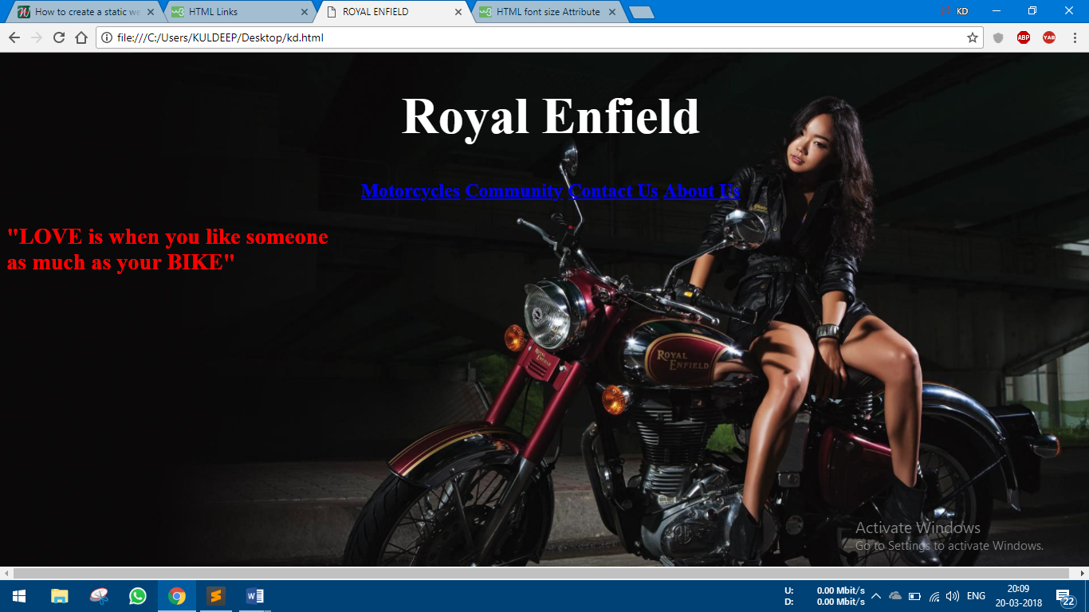

Aim: Installing Xampp on Computer

Xampp for windows 7 version provides an easy to install apache-mysql-php-perl-pear framework. Xampp saves time and effort and provides the software support for web frameworks like drupal, joomla, moodle, or wikimedia on any windows pc.

Steps:

1. Download the installer file for the latest version of XAMPP, and save the file to your computer

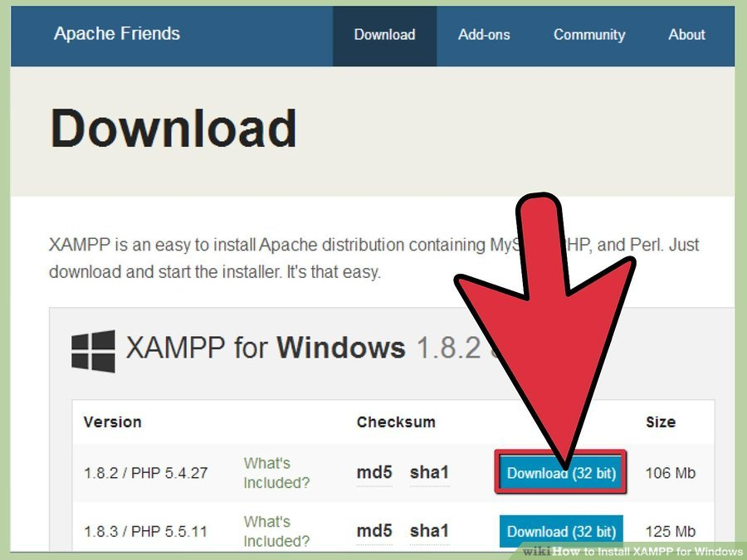

1. Open CD or DVD drive from My Computer. Install the program, and click on "Run
2. Accept the default settings. A command will open and offer an initial installation prompt. Just hit the Enter key, and accept the default settings. You can always change settings, by editing the configuration files later."
3. When your installation is complete, exit the command window by typing x on the command line
4. Start the XAMPP Control Panel

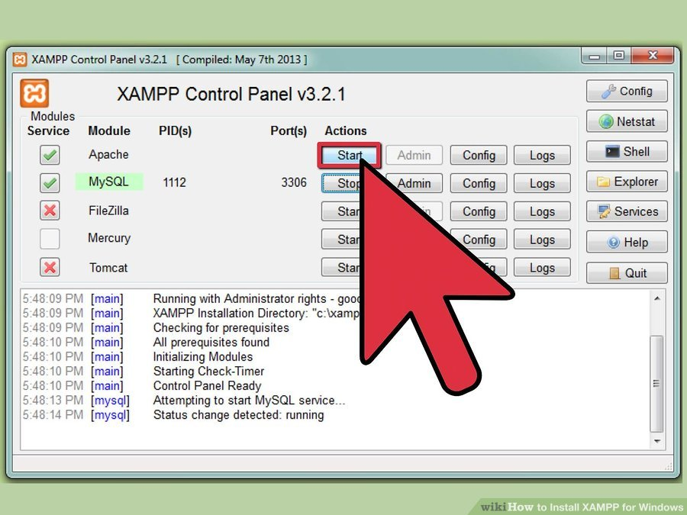

1. Start the Apache and mysql components. You can also start the other components, if you plan to use them
2. Verify the mysql installation, by clicking on the mysql administrative link in the XAMPP Control Panel.
3. If the verification steps are successful, XAMPP should be successfully installed on your PC. Open a browser and enter "localhost" on your address bar. You will be redirected to a page telling you that you've successfully installed xampp on your system

**WEEK -2**

Aim: CSS(Cascading style sheet) for web page

**PROGRAM:-**

<!DOCTYPE html>

<html>

<head>

<title>ROYAL ENFIELD</title>

</head>

<head>

<style>

body {

height: 100%;

width: 100%;

background-image: url(http://www.onlyhdpic.com/images/Collections/hd-pics-photos-stunning-attractive-royal-enfield-17-hd-desktop-background-wallpaper.jpg);

background-repeat: no-repeat;

background-size: cover;

}

h1 {

color: gray;

font-size: 50px;

text-align: center;

}

p {

color: lightgray;

text-align: right;

font-size: 20px;

font-family: calibri;

}

ul {

list-style-type: none;

margin: 0;

padding: 0;

overflow: hidden;

background-color: transparent;

}

li {

float: left;

}

li a {

display: block;

color: white;

text-align: center;

padding: 14px 16px;

text-decoration: none;

}

li a, .dropbtn {

display: inline-block;

color: white;

text-align: center;

padding: 14px 16px;

text-decoration: none;

}

li a:hover, .Motorcycles:hover .dropbtn {

background-color: #4CAF50;

}

li.Motorcycles {

display: inline-block;

}

.Motorcycles-content {

display: none;

position: absolute;

background-color: #f9f9f9;

min-width: 160px;

box-shadow: 0px 8px 16px 0px rgba(0,0,0,0.2);

z-index: 1;

}

.Motorcycles-content a {

color: black;

padding: 12px 16px;

text-decoration: none;

display: block;

text-align: left;

}

.Motorcycles-content a:hover {background-color: #f1f1f1}

.Motorcycles:hover .Motorcycles-content {

display: block;

}

</style></head>

<body>

<h1>Royal Enfield</h1>

<ul>

<li><a href="#home">Home</a></li>

<li class="Motorcycles">

<a href="javascript:void(0)" class="dropbtn">Motorcycles</a>

<div class="Motorcycles-content">

<a href="#">BULLET</a>

<a href="#">CLASSIC</a>

<a href="#">THUNDERBIRD</a>

</div>

</li>

<li><a href="#community">Community</a></li>

<li><a href="#contactus">Contact Us</a></li>

<li><a href="#aboutus">About Us</a></li>

</ul>

<p>"LOVE is when you like someone <br>

as much as your BIKE"

</p>

</body>

</html>

**SCREENSHOT:-**

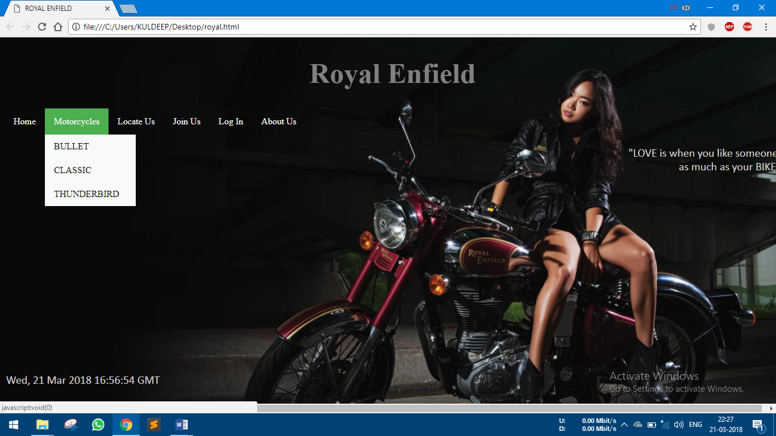

Aim: Create a simple Form in Css and Html

**PROGRAM:-**

<!DOCTYPE html>

<html>

<style>

h3{

text-align: center;

background-color: #4CAF50;

width: 100%;

padding: 12px 0;

margin: 10px 0;

border: 1px solid #ccc;

border-radius: 25px;

box-sizing: border-box;

}

input[type=text], select {

width: 100%;

padding: 12px 20px;

margin: 10px 0;

display: inline-block;

border: 1px solid #ccc;

border-radius: 25px;

box-sizing: border-box;

}

input[type=submit] {

width: 100%;

background-color: gray;

color: white;

padding: 14px 20px;

margin: 8px 0;

border: none;

border-radius: 50px;

cursor: pointer;

}

input[type=submit]:hover {

background-color: #45a049;

}

div {

border-radius: 30px;

background-color: lightgray;

padding: 30px;

}

</style>

<body>

<h3>Submit Your Details Here</h3>

<div>

<form action="/action_page.php">

<label for="name">Full Name</label>

<input type="text" id="name" name="firstname" placeholder="Your Name..">

<label for="mobile">Mobile No.</label>

<input type="text" id="mobile" name="mobileno" placeholder="10 Digit Mobile No.">

<label for="email">Email</label>

<input type="text" id="email" name="emailid" placeholder="Enter Your Email ID Here">

<label for="password">Password</label>

<input type="text" id="password" name="password" placeholder="New Password">

<input type="submit" value="JOIN">

</form>

</div>

</body>

</html>

SCREENSHOT

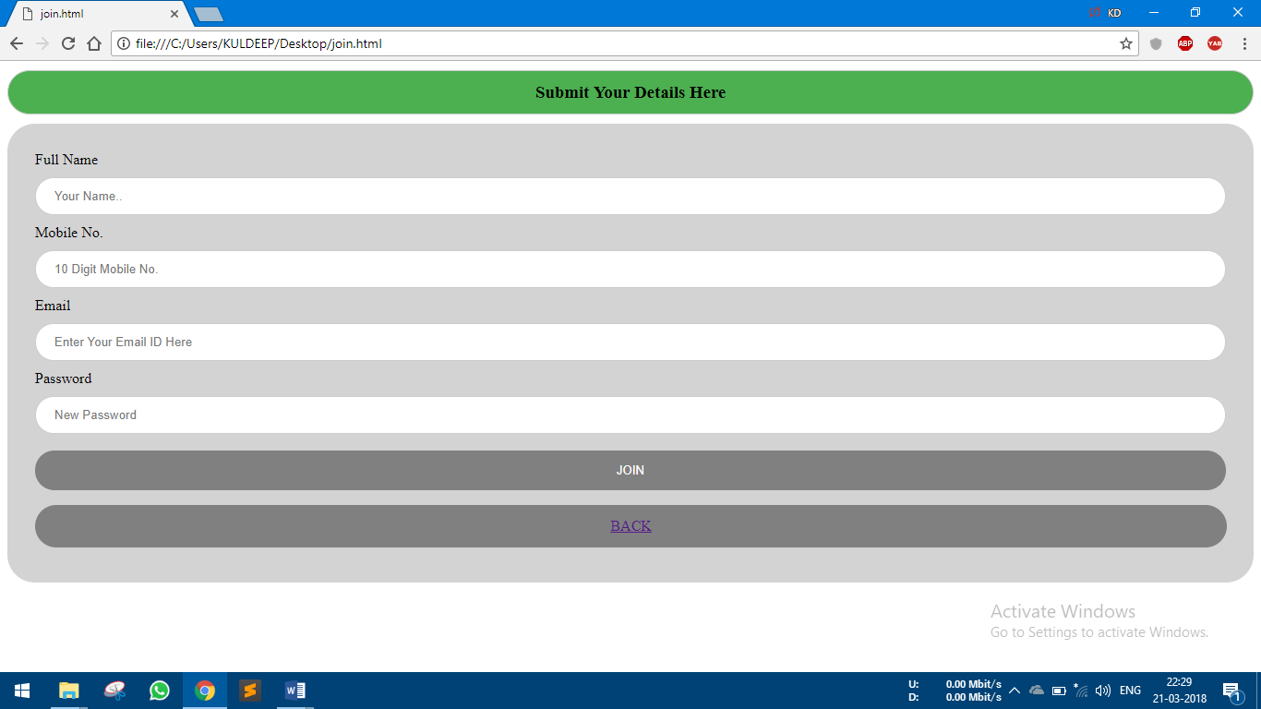

**WEEK -4**

Aim: Showing Current Date and Time

**PROGRAM:-**

<!DOCTYPE html>

<html>

<head>

<title>ROYAL ENFIELD</title>

</head>

<head>

<style>

body {

height: 100%;

width: 100%;

background-image: url(http://www.onlyhdpic.com/images/Collections/hd-pics-photos-stunning-attractive-royal-enfield-17-hd-desktop-background-wallpaper.jpg);

background-repeat: no-repeat;

background-size: cover;

}

h1 {

color: gray;

font-size: 50px;

text-align: center;

}

p {

color: lightgray;

text-align: right;

font-size: 20px;

font-family: calibri;

}

ul {

list-style-type: none;

margin: 0;

padding: 0;

overflow: hidden;

background-color: transparent;

}

li {

float: left;

}

li a {

display: block;

color: white;

text-align: center;

padding: 14px 16px;

text-decoration: none;

}

li a, .dropbtn {

display: inline-block;

color: white;

text-align: center;

padding: 14px 16px;

text-decoration: none;

}

li a:hover, .Motorcycles:hover .dropbtn {

background-color: #4CAF50;

}

li.Motorcycles {

display: inline-block;

}

.Motorcycles-content {

display: none;

position: absolute;

background-color: #f9f9f9;

min-width: 160px;

box-shadow: 0px 8px 16px 0px rgba(0,0,0,0.2);

z-index: 1;

}

.Motorcycles-content a {

color: black;

padding: 12px 16px;

text-decoration: none;

display: block;

text-align: left;

}

.Motorcycles-content a:hover {background-color: #f1f1f1}

.Motorcycles:hover .Motorcycles-content {

display: block;

}

</style></head>

<body>

<h1>Royal Enfield</h1>

<ul>

<li><a href="royal.html">Home</a></li>

<li class="Motorcycles">

<a href="javascript:void(0)" class="dropbtn">Motorcycles</a>

<div class="Motorcycles-content">

<a href="#">BULLET</a>

<a href="#">CLASSIC</a>

<a href="#">THUNDERBIRD</a>

</div>

</li>

<li><a href="#locate">Locate Us</a></li>

<li><a href="join.html">Join Us</a></li>

<li><a href="#login">Log In</a></li>

<li><a href="#aboutus">About Us</a></li>

</ul>

<p>"LOVE is when you like someone <br>

as much as your BIKE"

</p>

</body>

<head>

<style>

div.fixed {

position: fixed;

width: 20%;

bottom: 10px;

color: lightgray;

}

</style>

</head>

<body>

<div class="fixed">

<p id="demo"></p>

<script>

var d = new Date();

document.getElementById("demo").innerHTML = d.toUTCString();

</script></div>

</body>

</html>

**SCREENSHOT:-**

